**class diagram**

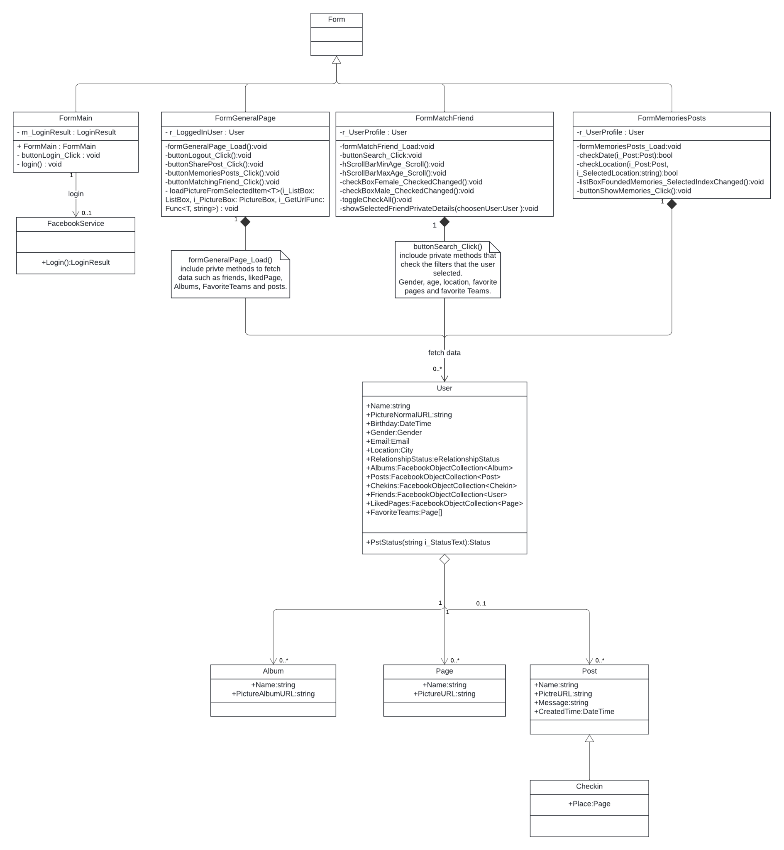

**Use case diagram**

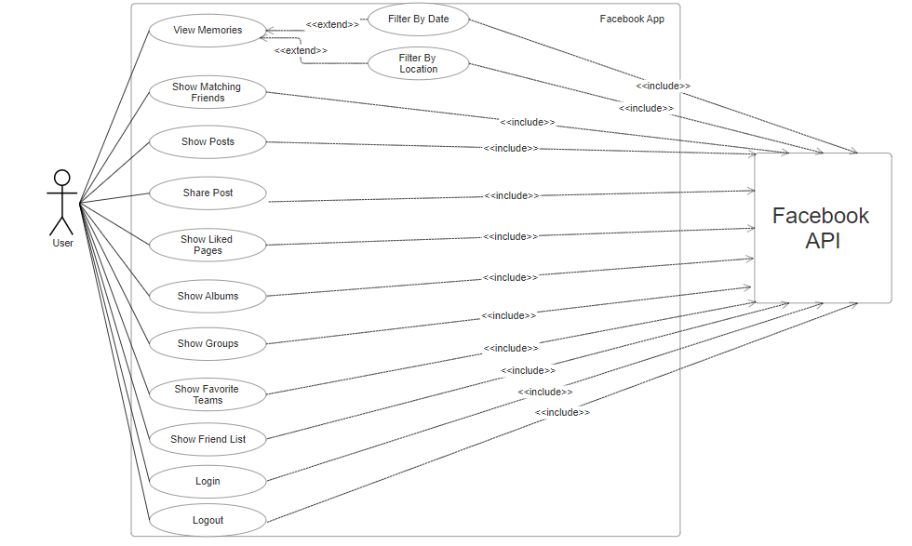

**Fitcher 1 : Search for memories post**

The user can filter his posts by location and date range, and recall moments in his life.

can be found on the general page on the bottom left under the name "Search Memories".

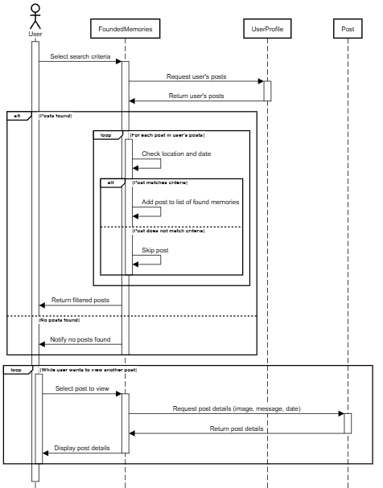

**Fitcher 2 : Matching friend**

The user will be able to filter the list of his friends according to certain criteria such as gender, age range, place of residence, pages that have been liked in common and shared favorite sports teams. After filtering, the user will be able to mark one of the members in the filtered list and his details will be displayed in front of him.

can be found on the bottom left of the main page under the name "Matching friend".

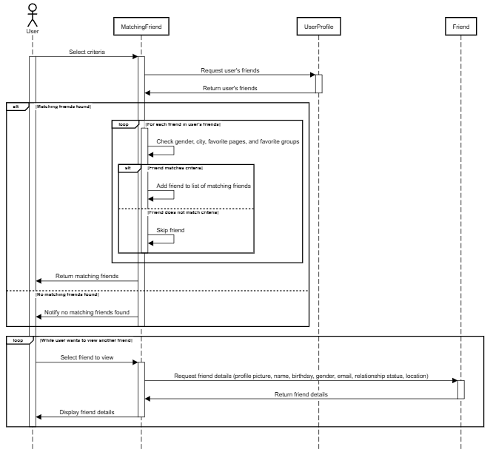

**Diagram Grade: 90**

**Comments:**

* **Class Diagram**

- Facebook API classes that are in use must be mentioned (-6)

* **Sequence Diagram**

- Fetching Posts and Friends from Facebook server takes time and thus must be indicated by a diagonal arrow (-4)